Publication: The Times Of India Pune; | Date: Jul 6, 2011; | Section: Times City; | Page: 4
Experts want townships, SEZs kept out of Western Ghats:
Ecology Panel set up by the Environment Ministry had sought views of other authorities on how to conserve the Region’s Biodiversity

By Dipannita Das ITNN
Pune: Efforts to conserve the biodiversity of the Western Ghats will climb the curve only if townships and special economic zones are not allowed here, a study on private ownership, commercial development and its impact on the ecosystem said. A separate report backed policies which will ensure that industries are not set up, steps to phase out the existing units, and no renewal of consent for polluting units from the control boards to save the eco-sensitive region. Both reports were commissioned by the Western Ghats ecology experts' panel that was set up last year by the ministry of environment and forests. The panel had sought suggestions from authorities to preserve the ecology of the Western Ghats.
The first report was compiled by Manasi Karandikar and Ketaki Ghate of Oikos, a nature and biodiversity conservation consultancy, while the second study on industrial pollution assessment was done by former MPCB Member Secretary Dilip Boralkar.
The legal framework, comprising a hill-station policy, environmental internal assessment or environmental sanction, was not enough to protect the ecosystem of the Western Ghats as the policies and guidelines set by government are rarely followed, the first study concluded. This report was based on the consultancy's experience in ecological assessments of various lands, restoration work and general observations since 2001, Ghate said. The firm has worked with local communities and studied forests, land use, ecosystems and biodiversity, private land owners, developers and township development.
A detailed study of the effect of development on ecosystems and its long-term negative impacts was necessary, she said. Loss to the ecosystem is inevitable, she added. “Developmental activities like roads, establishments, buildings and quarries destroy existing landscapes including slopes, streams, plateaus, valley bottoms, fertile rice fields, biodiversity, habitats, soil structure, hydrology,” the report said. Compensatory measures like planting 1,000 trees per hectare does not compensate for the loss, it added.
Declaring areas in the Western Ghats and those in the catchment of major dams as 'hill-station zones' contradicts the policy. The government already has a catchment area treatment guideline for dams to prevent siltation. No- objection certificates (NOC) and clearance certificates never look into the finer details of site-specific negative impacts, hence all such certificates are inadequate, the report said.
The tourism industry lacks proper policies, hence there is no control over the type and scale of development, the study noted. It suggested a control over the number of tourists allowed per year and basic facilities instead of urban lifestyle amenities. The report on industrial pollution said factories cause air pollution due to industrial process and burning of fossil fuel and discharge about 6,78,000 cubic m of effluents.
The Central Pollution Control Board has put as many as 234 large scale units in the highly polluting (red) category, it added. The report listed thermal power plants, mining operations, chemical and petrochemical industries, metallurgical units, ports and harbour activities, tourism, infrastructure development, fisheries and disposal of industrial effluents as pollutants. The panel must decide whether the Western Ghats should be left out of any industrial development on the principle that loss of industries can be compensated, but loss of biodiversity is irreversible, Boralkar said. There is support for green industries, he said. “But, infrastructure, requirement of electricity, transportation, habitation and roads that come with industries, put pressure on the ecosystem,” he added. The areas in the Western Ghats which will be declared fragile by the panel must be made into 'no-go' areas for industrial development of any kind. Mining should not be permitted in such areas since it cannot co-exist with biodiversity, Boralkar said. The paper said that the Planning Commission's thrust on restricting and re-orienting development work in the region was not based on demarcation of physical boundaries.
SUGGESTIONS
* The proposed panel must complete a status survey of the industries in Western Ghats and evaluate them. The primary consideration would be protection and enhancement of biodiversity
* Policies should not permit any further investment in those industries which are listed and which cannot be permitted in the Western Ghats (thermal power plants and mining industries)
* It should examine the record of existing small industries, cottage or soft industries and make recommendations
* The panel should examine possibilities of economic development based on sustainable use of natural resources. For example, instead of extracting and marketing iron ore, small units may be encouraged to protect water sources
* Industries which deal with biodiversity conservation including vermin-culture, apiaries, nature rehabilitation work, afforestation work, nurseries, harvesting of timber from private plots, cane crafts and several other income-generating activities (including small scale eco-tourism) could be the basis for a sustainable development plan
* The panel may suggest creative ways in which persons living in this area would have a right to exploit in a sustainable manner the natural resources
How to save the Western Ghats
* Treat it like an afforestation zone * No permission for townships / hill cities / hill towns
Zoning of entire range for:
* No intervention: Existing national parks, sanctuaries, reserved forests and their buffers, sacred groves, inaccessible patches
* Buffer for eco-restoration: Have a 10-m buffer on either side of streams and streamside vegetation, steep slopes, mountain tops.
* Residential: Existing Gaothan / wadi with surrounding buffer of 200 m, allow traditional areas of cultivation on level land, moderate slopes with scrub vegetation.
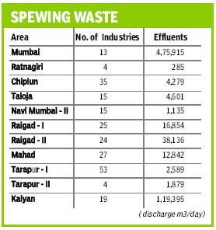 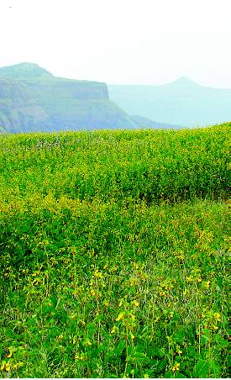
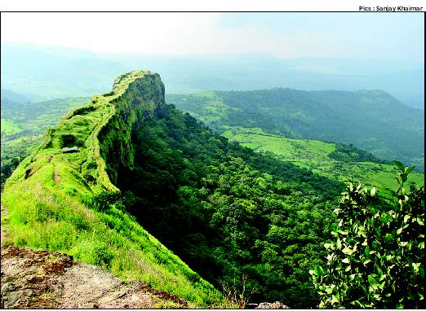
Experts say the Western Ghats must be declared a no-go area for industrial development

